

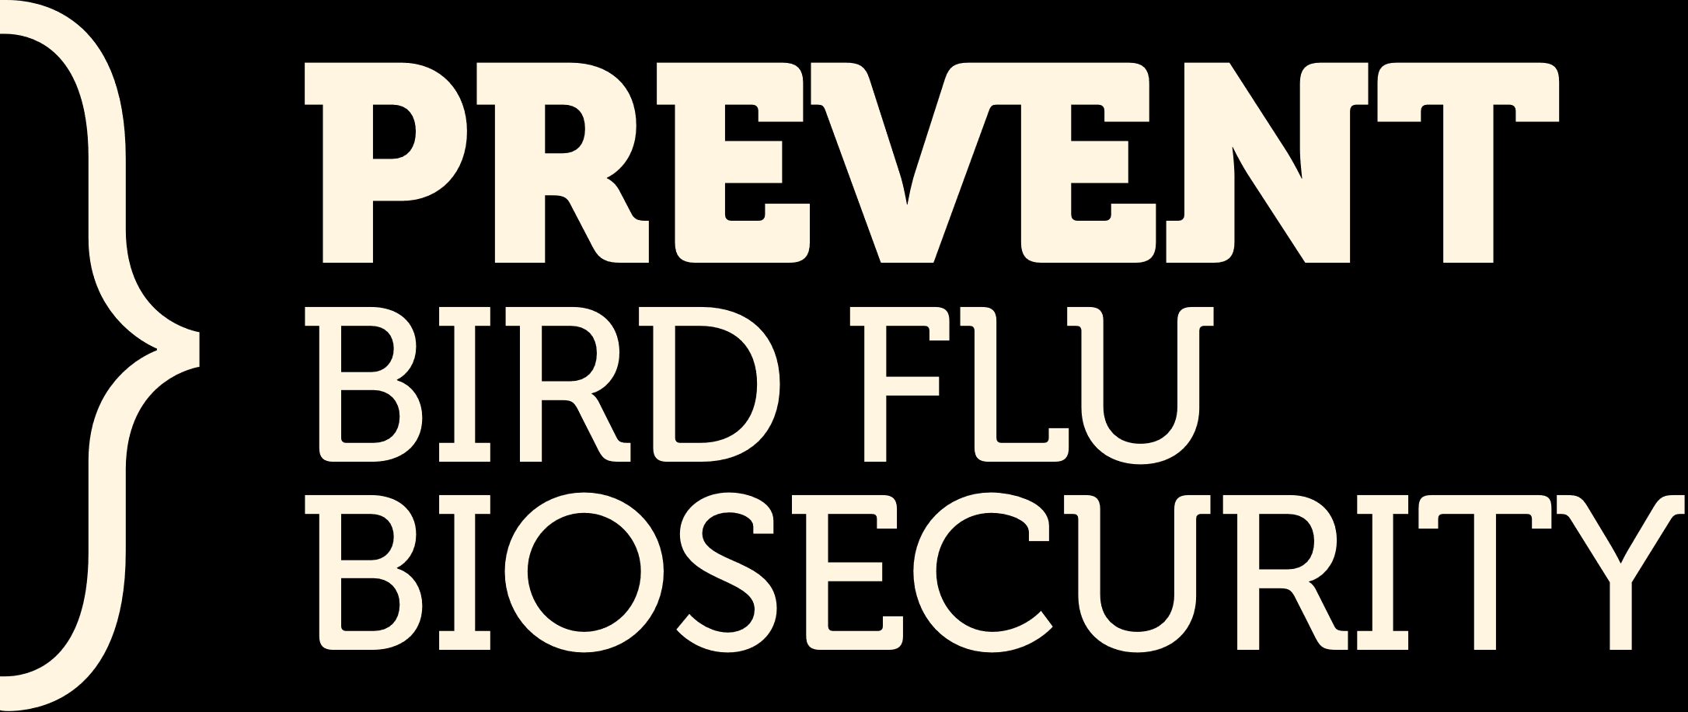

TEMPLATE

DISEASE PREVENTION BIOSECURITY PLAN
Contents
1.Purpose 2
1.1 Embedding Biosecurity Procedures into Day-to-Day Work 2
2.Farm Production Area Map 3
3. Personnel Responsibilities, Competencies & Training 4
4. Farm Biosecurity Procedures 5
4.1 People, Vehicle & Equipment Movement Procedures 5
4.2 Internal (Bird Production Areas) Biosecurity Procedures 8
4.3 Litter Management Procedures 9
4.4 Manure Management Procedures 10
4.5 Pest Management Procedures 11
4.6 Water Supply Management Procedures 13
4.7 Design & Construction and Repairs & Maintenance Procedures 14
4.8 Depopulation Procedures 15
4.9 Disposal Procedures 16
4.10 Decontamination (Cleaning & Disinfection) and Ground Maintenance Procedures 17

If you already have biosecurity procedures and records in place, you are not required to fill in this template. It is provided as a helpful resource and an optional tool for producers who want a structured way to record their biosecurity practices.

1.Purpose

This Template is your farm’s biosecurity procedures template. You can use it to write down how you manage biosecurity on your farm, using the guidance in the Disease Prevention Biosecurity Plan Template to help you decide what to include.

You can fill in this Template by hand or use the digital version to type up your procedures. Once you’ve completed it, you can:
- keep the Template somewhere staff can easily find it
- save a digital copy for your records
- print out individual procedures and pin them up in the areas where the work happens

This means your team can quickly and clearly see what they need to do.

Some of the biosecurity practices in this Template might already be covered in your Risk Management Programme (RMP). If that’s the case, you don’t need to repeat everything, just write down which part of your RMP covers that requirement. Likewise, if you have fully documented standard operating procedures, simply reference the relevant document.

The procedures you write in this Template will only work if they become part of normal, everyday farming. When everyone on the farm knows what to do and why they’re doing it, biosecurity becomes much easier to manage.

1.1 Embedding Biosecurity Procedures into Day-to-Day Work
There are many ways to ensure procedures are consistently applied. Some options to consider include:
- Training
Ensure all staff are trained in the procedures and receive regular refresher training.
- Involvement in Development
Involve the farm team when developing or adapting procedures so they understand them and have ownership.
- Explain the “Why”
When people understand why a procedure is important, they are far more likely to follow it.
- Easy Access to Procedures
Make procedures clearly accessible. Where a procedure relates to a specific task or area, display it on the wall in that area for quick reference.
- Keep Procedures Current
Review procedures regularly to ensure they accurately reflect what happens on-farm and that farm practice aligns with the documented procedures.

2.Farm Production Area Map

Insert your farm production area biosecurity map here:

3. Personnel Responsibilities, Competencies & Training

Staff responsible for the care of birds must be competent, well-trained, and work to at least the minimum standards required by the Poultry Biosecurity Code of Practice. Using Section 3. of the Disease Prevention Biosecurity Plan Template, complete the template below to show how you achieve this.

Farm Procedure
Describe staff inductions for biosecurity:

Records kept:

Describe refresher training for biosecurity:

Records kept:

Enhanced Biosecurity Measures

4. Farm Biosecurity Procedures

4.1 People, Vehicle & Equipment Movement Procedures

Clear controls on how people, vehicles, equipment, and contractors enter and move around the farm are essential to maintaining strong biosecurity. Using Section 4.1 of the Disease Prevention Biosecurity Plan Template, complete the templates below to show how you achieve this.

Farm Procedure
Describe general movement controls for people when entering and moving around the property:

Records kept:

Describe general movement controls for vehicles when entering and moving around the property:

Records kept:

Describe general movement controls for equipment when being brought onto and moved around the property:

Records kept:

Enhanced Biosecurity Measures

Staff Biosecurity Controls
Farm Procedure
Describe specific staff biosecurity controls when entering and moving around the property:

Records kept:

Describe any declarations staff make related to keeping or recent contact with birds (including wild birds), other farm animals, or high‑risk environments:

Records kept:

Enhanced Biosecurity Measures

Visitor/Contractor Biosecurity Controls
Farm Procedure
Describe specific visitor and contractor biosecurity controls when entering and moving around the property:

Records kept:

Describe any declarations visitors and contractors make related to keeping or recent contact with birds (including wild birds), other farm animals, or high‑risk environments:

Standdown requirements:

Records kept:

Enhanced Biosecurity Measures

4.2 Internal (Bird Production Areas) Biosecurity Procedures

Movements into poultry housing and production areas is one of the highest-risk pathways for transferring disease, and contaminants from one group of birds to another and therefore warrants specific focus. Each shed, barn or range should therefore be treated as a separate biosecurity unit, with staff, equipment, and vehicles moving in a controlled, defined manner that protects the health and welfare of all flocks on the farm. Using Section 4.2 of the Disease Prevention Biosecurity Plan Template, complete the template below to show how you achieve this.

Farm Procedure
Describe the controls in place to prevent staff, visitors, and contractors from entering a biosecurity unit (e.g., shed, barn, or range):

Records kept:

Describe the biosecurity procedure required when entering or exiting a biosecurity unit (e.g., shed, barn, or range):

Records kept:

Enhanced Biosecurity Measures

4.3 Litter Management Procedures

Good litter practices help reduce dust, fungal growth, and wet patches that can attract vermin, compromise bird welfare, increasing susceptibility to disease. Using Section 4.3 of the Disease Prevention Biosecurity Plan Template, complete the template below to show how you achieve this.

Farm Procedure
Describe the procedure for litter quality management:

Records kept:

Describe the monitoring process in place to manage dust and dampness in barn litter (e.g. shavings):

Records kept:

Describe the procedure for litter delivery management:

Records kept:

Enhanced Biosecurity Measures

4.4 Manure Management Procedures

Manure buildup can create risks for bird welfare and biosecurity by contributing to odour, attracting vermin, and enabling disease transmission. Litter must be actively managed to prevent dampness, mould, and pest attraction. Using Section 4.4 of the Disease Prevention Biosecurity Plan Template, complete the template below to show how you achieve this.

Farm Procedure
Describe the procedure for managing manure in housing:

Records kept:

Describe the procedure for managing manure in the range:

Records kept:

Describe the procedure for managing manure in storage:

Records kept:

Enhanced Biosecurity Measures

4.5 Pest Management Procedures

A robust pest-management plan, regularly monitored and adjusted, helps prevent pests from entering bird housing, feed storage areas, and manure-storage locations. Managing pests reduces the likelihood of disease transmission, contamination, and structural damage around production areas. Using Section 4.5 of the Disease Prevention Biosecurity Plan Template, complete the template below to show how you achieve this.

Farm Procedure & Pest Control Site Map
Draw a site map showing the location of all pest control devices on the farm (number each device and record the details below):

No. | Location | No. | Location | No. | Location

Detail the types of bait stations / traps used on the farm:

What is the frequency with which the bait stations or traps are checked?

Records kept:

Enhanced Biosecurity Measures

4.6 Water Supply Management Procedures

Good-quality water is essential for maintaining bird welfare, supporting production, and ensuring strong farm biosecurity. Any water sourced from outside local-authority supply, or stored on farm, must be tested regularly to confirm it is safe and suitable for poultry use. Using Section 4.6 of the Disease Prevention Biosecurity Plan Template, complete the template below to show how you achieve this.

Farm Procedure
Describe the farm’s water supply sources:

Describe the farm’s water supply / storage capacity:

Describe the farm’s water supply back up for the birds:

Describe the farm’s water supply checks:

Records kept:

If the water is treated, what procedures, checks, or tests are required for the treatment system?

Records kept:

Enhanced Biosecurity Measures

4.7 Design & Construction and Repairs & Maintenance Procedures

All buildings, facilities, and equipment on the farm must be designed, constructed, installed, and operated in a way that prevents or minimises contamination of products, packaging, inputs, equipment, and the wider processing environment. Using Section 4.7 of the Disease Prevention Biosecurity Plan Template, complete the template below to show how you achieve this.

Farm Procedure
Describe the structural elements that minimise the entry or harbourage of pests, including wild birds:

Records kept:

Describe how you maintain optimum cleanability of all surfaces (e.g., ensuring they are smooth, durable, impervious, and free of gaps, cracks, and crevices):

Records kept:

Describe how external water is prevented from entering the sheds (water ingress):

Records kept:

Enhanced Biosecurity Measures

4.8 Depopulation Procedures

Strengthening your routine depopulation procedures ensures that, if a response is ever needed, the farm is already equipped with clear expectations, trained personnel, and reliable systems that minimise biosecurity risk. Using Section 4.8 of the Disease Prevention Biosecurity Plan Template, complete the template below to show how you achieve this.

Farm Procedure
Indicate the methods used for bird depopulation on the farm:

Describe the procedure that trained staff follow to carry out depopulation of birds, based on the method(s) indicated above:

Records kept:

Enhanced Biosecurity Measures
Guidance for enhanced procedures for depopulation can be found in the Disease Response Biosecurity Plan Guidebook and should be recorded within the Disease Response Biosecurity Plan Template.

4.9 Disposal Procedures

Well defined, consistently implemented disposal procedures help minimise the risk of introducing or spreading disease when handling, transporting, and disposing of mortalities and contaminated materials. Using Section 4.9 of the Disease Prevention Biosecurity Plan Template, complete the template below to show how you achieve this.

Farm Procedure
Describe the procedure for dead bird disposal:

Records kept:

Describe the procedure for litter disposal:

Records kept:

Enhanced Biosecurity Measures
Guidance for enhanced procedures for disposal can be found in the Disease Response Biosecurity Plan Guidebook and should be recorded within the Disease Response Biosecurity Plan Template.

4.10 Decontamination (Cleaning & Disinfection) and Ground Maintenance Procedures

Maintaining a clean environment is essential for biosecurity, particularly when preparing housing for a new batch of birds. The areas surrounding production sheds should also be kept clean and tidy, with grass and vegetation controlled to reduce the risk of attracting vermin and wild birds.

Farm Procedure
Describe the decontamination procedure for the housing between batches of birds:

Records kept:

Describe the cleaning requirements for the housing while birds are present:

Records kept:

Describe the cleaning requirements for bird transport equipment and/or containers used for transport:

Records kept:

Describe the cleaning processes used for the bird ranges:

Records kept:

Enhanced Biosecurity Measures
Guidance on enhanced decontamination procedures is available in the Disease Prevention Biosecurity Plan Template. If decontamination is required due to a disease incursion on farm, those procedures should be recorded in the Disease Response Biosecurity Plan Template. All other enhanced decontamination procedures can be documented here.

